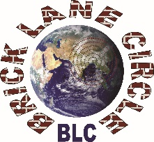
Brick Lane Circle

Knowing One Another Through Philosophy
Application Form – Volunteer Participant

Kindly familiarise about the project before completing the application form. It is important that you fully understand and appreciate the nature of the commitment involved on your part.

Please request further information on the project or submit your completed application form through email.

Application Deadline: 31 May 2021
bricklanecircle@yahoo.co.uk
The information you supply on this form will be treated in confidence.

Personal details

First name: | Surname:
Address:

Email: | Telephone:
Age: | Gender:
Ethnicity:
List other protected characteristics:
Qualifications (including GCSEs, A Levels and Degrees):
Please use this section to show how your backgrounds, knowledge, experience and skills will enable you to effectively participate in the project as a volunteer participant. Also state how you will benefit from your participation with the project. (450-word limit)
Who should apply?
Ordinary members of London’s diverse communities, with a special focus on people living in East London and from different walks-of-life, are invited to apply.

This project is particularly suitable for individuals who are interested in exploring, through philosophy, community cohesion issues and problems that we face linked to race, ethnicity, culture and faith.

We are not looking for professional philosophers or established academics and writers to join the project.

Please sign and date before submitting to application to bricklanecircle@yahoo.co.uk
SIGNATURE:

DATE:

